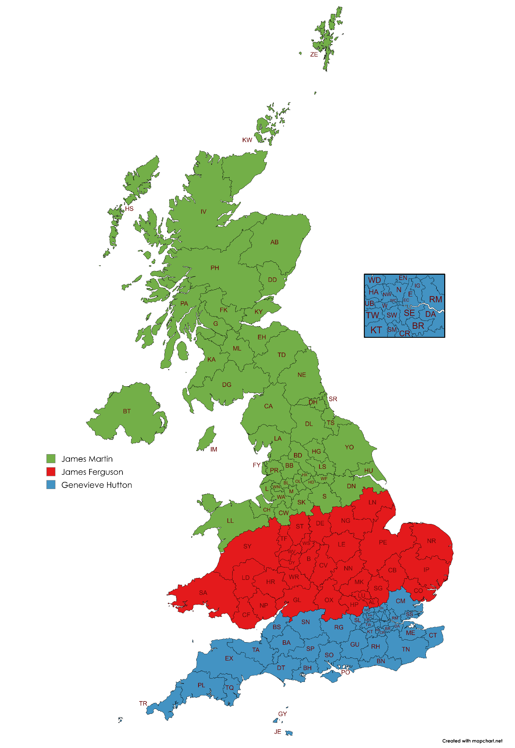
Showersave Contact Sheet

Alex Parkinson
Sales Director
National
M: 044 7802 471 353
E: alexparkinson@showersave.com

James Martin
Regional Business Manager
Northern England | North Wales | Scotland | Northern Ireland
M: 07512 304 023
E: jamesmartin@showersave.com

James Ferguson
Regional Business Manager
Midlands | Wales | North Home Counties
M: 07802 416887
E: jamesferguson@showersave.com

Genevieve Hutton
Regional Business Manager
South England | London | Southern Home Counties
M: 07850 206 314
E: genevievehutton@showersave.com

Steve Parker
Head of Social Housing
National
M: 07802 482 009
E: steveparker@showersave.com

